Oef 7

%oef7a

%initiele condities

y0=[0.01 0.01 30 0 0 0 30 0];

%tijdsduur

tspan=[0 40];

%solver oproepen

[t y]=ode45(@oef7_vgl,tspan,y0);

%resultaat plotten

plot(t,y(:,1),'b:',t,y(:,2),'r-',t,y(:,3),'g-',t,y(:,4),'k-')

xlabel('Tijd (h)')

ylabel('Concentratie (kg/m^3)')

legend('Xtot1', 'X1', 'S1','P1')

%oef7b

%initiele condities

y0=[0.01 0.01 30 0 0 0 30 0];

%tijdsduur

tspan=[0 40];

%solver oproepen

[t y]=ode45(@oef7_vgl,tspan,y0);

plot(t,y(:,5),'b-',t,y(:,6),'r-',t,y(:,7),'g-',t,y(:,7),'k-')

xlabel('Tijd (h)')

ylabel('Concentratie (kg/m^3)')

legend('Xtot2', 'X2', 'S2','P2')

function [ ydot ] = oef7_vgl( t,y )

umax = 1.6;

Ks=0.22;

Kp=9.5;

Kd0=0.08;

a=0.0065;

ys=0.13;

ds=0.128;

yp=0.2;

dp=0.04;

V1=1;

F1=1.5;

B1=0.3;

V2=V1;

F2=F1;

B2=B1;

Pf1=0;

Pf2=0;

Sf1=30;

Sf2=30;

D1=F1/V1;

D2=F2/V2;

Xtot1=y(1);

X1=y(2);

S1=y(3);

P1=y(4);

Xtot2=y(5);

X2=y(6);

S2=y(7);

P2=y(8);

kd1=Kd0*(1+a*P1);

kd2=Kd0*(1+a*P2);

u1=umax*S1/(Ks+S1)*Kp/(Kp+P1);

u2=umax*S2/(Ks+S2)*Kp/(Kp+P2);

rs1=u1/(ys+ds*u1);

rs2=u2/(ys+ds*u2);

rp1=u1/(yp+dp*u1);

rp2=u2/(yp+dp*u2);

ydot=[-B1*Xtot1*D1+u1*X1

-B1*X1*D1+u1*X1-kd1*X1

D1*Sf1-D1*S1-rs1*X1

D1*Pf1-D1*P1+rp1*X1

-B2*Xtot2*D2+u2*X2+B1*D2*Xtot1

-B2*X2*D2+u2*X2+B1*D2*X1-kd2*X2

D2*Sf2+F1*S1*B1/V2-(B1*F1+F2)*S2/V2-rs2*X2

D2*Pf2+F1*P1*B1/V2-(B1*F1+F2)*P2/V2+rp2*X2];

end

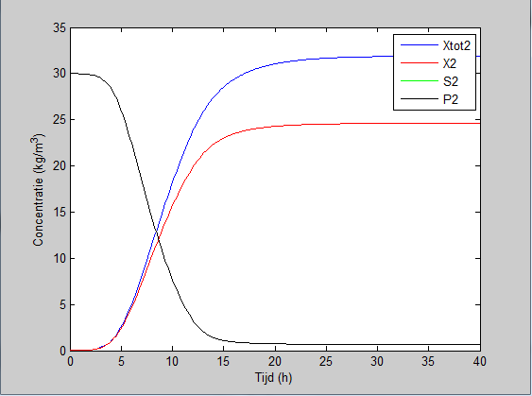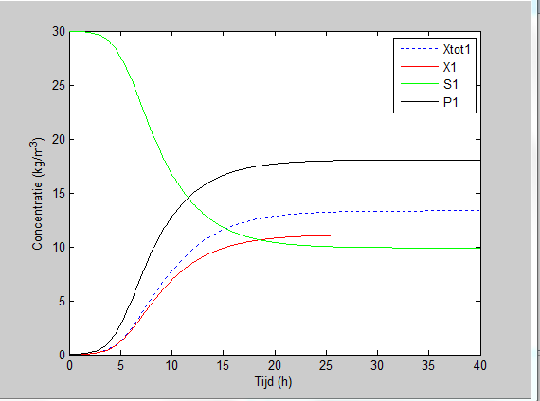

B=0.2

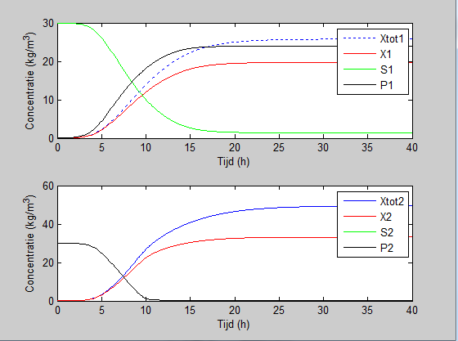

B=0.3

